Report of Head of Law and Governance
To
Polling Places Sub Committee
On
15 December 2020
ELECTORAL REVIEW

- SUMMARY

The purpose of this report is to present information to the Sub Committee to enable it to make a recommendation on the future Council size to Council.

Key Decision – This is not a key decision.

2. RECOMMENDATIONS

- That the Committee determine whether single, multi or mixed member ward be recommended to Council as part of stage one of the Electoral review
- That the Committee determine its recommendation to Council on the future size of the Council and identify the reasons for the recommendation.

3. BACKGROUND

3.1 Members will be aware that the Local Government Boundary Commission (LGBC) have advised that it is to undertake an electoral review of the Council. This review has been triggered as a result of the electoral imbalances which have arisen in more than 30 per cent of the council’s wards. These electoral imbalances arise if voters are either over or under represented by their councillor when compared with average representation across the authority.

3.2 The review process is split over 2 stages with the purpose stage one being to consider the number of councillors elected to the council (council size). Also in stage 1 the council will need to determine if single member wards are to remain, or if multi member wards are to be reintroduced. Stage 2 relates to the names, number of wards and boundaries of wards.

3.3 The Commission will expect to see evidence that several different options for council size have been assessed in recommending a council size, this should be done irrespective of whether the council recommends the same or a different number of elected members that it currently has.

3.4 The LGBC state that whilst the final decision on council size (number of councillors) rests with the commission itself, it believes the approach should be one of dialogue with the Council being reviewed. The Commission believes that a ‘good’ review is one where the local authority engages with the process and will be informed by locally generated proposals underpinned by evidence.

3.5 A working group comprising members of the Committee was established following the meeting of the Committee on 29 October 2020, to meet with various officers and assess the varied information needed to assist the Committee to recommend the future council size.

3.6 This information included -

- Council size from comparable authorities
- Results from a Members survey undertaken on various issues relating to membership of the Council
- Committee and outside body appointments
- Options on future council size
- Alternative arrangement for delivering Overview and Scrutiny

4. COMPARABLE AUTHORITIES

4.1 The Commission will refer to the CIPFA Nearest Neighbours Model for English authorities to help understand the contextual position of the authority being reviewed.

4.2 The ‘Nearest Neighbours’ are groups of statistically similar councils. The Council’s Nearest Neighbours and their respective Council size can be seen in the table below (Bassetlaw is not part of Mansfield’s ‘Nearest Neighbours’ but has been included for information).

 | Wards | Councillors | Members in Ward
Chesterfield | 19 | 48 | 2/3
Hyndburn | 16 | 33 | 1/2/3
Nuneaton and Bedworth | 17 | 34 | 2
Burnley | 15 | 45 | 3
Ashfield | 23 | 35 | 1/2/3
Cannock Chase | 15 | 41 | 2/3
Carlisle | 13 | 38 | 2/3
Pendle | 20 | 46 | 2/3
Tamworth | 10 | 30 | 3
Erewash | 19 | 47 | 2/3
Gloucester | 18 | 39 | 1/2/3
Wellingborough | 16 | 35 | 2/3
Newcastle-Under-Lyme | 21 | 44 | 1/2/3
Redditch | 12 | 29 | 2/3
Bolsover | 17 | 37 | 1/2/3
Bassetlaw | 25 | 48 | 1/2/3
Mansfield | 36 | 36 | 1

4.3 As this table shows, this District is unique in that it is the only one of its ‘Nearest Neighbours’ group to have only single Member wards.

4.3 Members are reminded of the recent motion agreed by Council on 2 December 2020, relating to the continuation of single member wards.

5. RESULTS FROM MEMBERS’ SURVEY

5.1 A survey was conducted between 3 and 15 November 2020 with the aim of acquiring information from Members to help inform the Polling Places Sub Committee. These questions asked for Members views on single or multi member wards, whether the number of councillors should change, and what they felt was needed for fair and effective governance.

5.2 28 Members took part, representing a 75% response rate. The main findings from these responses were that 100% considered that single member wards was the most appropriate option for the Council and that 71% believed that the number of Councillors should remain the same. A full list of the questions asked and the responses to these questions can be found in Appendix 1.

5.3 At the last meeting of the Working Group members agreed to send a supplementary questionnaire to councillors asking them to provide information relating to their ward role.

5.4 The results of the survey will be considered and presented to the Extraordinary Council in January 2021.

6. COMMITTEE MEMBERSHIP AND APPOINTMENT TO OUTSIDE BODIES

6.1 Details were provided on the allocation of committee seats on committees and how this may influence future council size to ensure effective governance and division of corporate decision making. Below is a table of the number of seats to be filled given the current structure of Overview and Scrutiny and Statutory Committees. These seats will mostly be filled by non-executive members as Executive members cannot sit on Overview and Scrutiny Committees or the Governance and Standards Committee.

Number of seats to be filled in current structure
Planning Applications Committee | 11 seats
Licensing Committee | 11 seats
Governance and Standards Committee | 9 seats
Overview and Scrutiny (Communities and Services) | 9 seats
Overview and Scrutiny (Place) | 9 seats
Overview and Scrutiny (Corporate Resources) | 9 seats
Joint Consultative Committee | 8 seats
Health and Safety Committee | 7 seats
Personnel Committee | 10 seats (11 including Mayor)
Polling Places Review Committee | 7 seats
Appeals Panel | 12 seats
Total seats to fill | 102

6.2 The working group noted that there was an unequal spread of current Committee membership; with some Councillors sitting on no Committees whilst others seat on multiple Committees.

6.3 Members also considered the structure and how the Council undertook its Overview and Scrutiny function.

6.4 Details were also provided on the appointments to outside bodies made by both the Elected Mayor and Council and how they were spread across the Council membership.

7. OPTIONS

7.1 Members considered four options for what the future of the Council size might be.

7.2 Both the Council’s Constitution and the law enables the Elected Mayor to appoint between two to nine Councillors to serve on the Cabinet.

7.3 Option 1. Retain 36 Councillors

7.4 Depending on the number of Executive appointments a minimum of 27 councillors would be available to sit on Overview and Scrutiny and Statutory Committees.

7.5 Option 2 – 34 Councillors

7.6 Depending on the number of Executive appointments a minimum of 25 councillors would be available to sit on Overview and Scrutiny and Statutory Committees.

7.7 Option 3 – 32 Councillors

7.8 Depending on the number of Executive appointments a minimum of 23 councillors would be available to sit on Overview and Scrutiny and Statutory Committees.

7.9 Option 4 – 38 Councillors

7.10 Depending on the number of Executive appointments a minimum of 29 councillors would be available to sit on Overview and Scrutiny and Statutory Committees.

7.11 In considering the future Council size the Working Group also felt that the deprivation level of wards would have a significant impact on the amount of constituency matters raised with the ward councillor, in that a councillor representing a deprived area would have a larger and more complex constituency caseload than those representing more affluent wards. Further communities of residents had been identified mostly within these deprived wards where English was not their first language which has impacted on the members representing them.

7.12 The Covid 19 pandemic had also impacted on how councillors communicated with their residents and undertook their community leadership role. It was noted that while technology and digital meetings had been used, to ensure that members were able to continue their community responsibilities, not all residents were comfortable or familiar with its operation and members felt that this should not be overlooked by the review.

8 OPTIONS AVAILABLE

To recommend either single, multi or mixed wards and the future council size of the authority.

9. RISK ASSESSMENT OF RECOMMENDATIONS AND OPTIONS

Risk | Risk Assessment | Risk Level | Risk Management
Democratic | By submitting a robust and well evidenced case to the LGBC on its future Council size and warding arrangements, the Council will ensure it passes on its own knowledge of its governance arrangements and community needs and influences the LGBC’s final recommendations | Low | Delegation of the detailed work in preparing the Council’s submissions to this Committee enable it to provide a robust submission to the LGBC in accordance with its timetable.

10. ALIGNMENT TO COUNCIL PRIORITIES

The electoral review is being directed by the LGBC, however, the Council is best placed to submit a case which meets the Council’s objectives and needs.

11. IMPLICATIONS

- Relevant Legislation – S.56 of the Local Democracy, Economic Development and Construction Act 2009 requires that the LGBC review “from time to time” every principal Local Authority Area in England and make recommendations about electoral arrangements and in addition, the LGBC can at any time review the arrangements for all or any part of a Principal Local Authority’s area if it appears to be desirable.

- Human Rights – There are no direct implications to individual human rights at this stage.

- Equality and Diversity – no direct implications

- Climate change and environmental sustainability – No direct implications.

(e) Crime and Disorder – No direct implications.

(f) Budget /Resource – no direct implications

12. COMMENTS OF STATUTORY OFFICERS

(a) Head of Paid Service – The requirement as set out in Boundary Commission Guidance invites a Council’s members to provide recommendations to inform the Council size and the distribution of councillors to wards. It is important that the council’s members inform this work and the Working Group has positively engaged in this work assisted and informed by a survey where all members were invited to contribute. It is for the Boundary Commission to receive these recommendations alongside any further submissions received from other stakeholders. The final decision is for the Boundary Commission to recommend to Parliament for adoption at the Council’s next Council Election.
(b) Monitoring Officer – own report

(c) Section 151 Officer – no specific comments

13. BACKGROUND PAPERS

None

Report Author | - | Mark Pemberton
Designation | - | Democratic Services Manager
Telephone | - | 01623 46330
E-mail | - | mpemberton@mansfield.gov.uk

Appendix 1: Results from the Members’ Survey

Background Information

Methodology

Planning the Consultation

Representatives from Democratic Services and the Polling Places Sub Committee were involved in the planning of the consultation exercise. The monitoring of returned responses, data input and results analysis was conducted by the Policy and Information Officer.

The Survey

The survey consisted of 14 questions. These questions aimed to acquire as much information from Members as possible in order to inform the Polling Places Sub Committees recommendations for stage 1 of the Boundary Review (Council size). Therefore the survey asked questions relating to hours worked, single member or multi member wards, and what is needed in order to provide fair and effective governance.

The Survey Process

The consultation period ran between Tuesday 3rd November and Sunday 15th November.

Analysis

The online responses were downloaded via an excel file and exported directly for analysis.

Thematic analysis was conducted on the open ended questions (which are known as qualitative responses). This is a type of analysis which identifies the most common themes in open ended written responses.

Results

28 responses to the survey were received, resulting in a 75% response rate.

On average, how many hours a week do you spend attending formal meetings of the Council? (such as Council, Cabinet, Committees etc)? (%)
On average, how many hours a week do you spend preparing for meetings (such as reading background papers and reports)? (%)
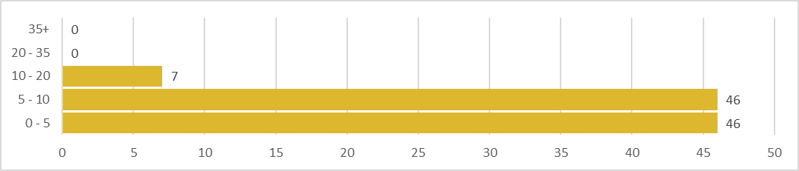
On average, how many hours a week do you spend attending meetings for outside bodies? (%)
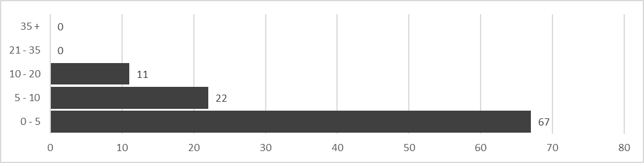
On average, how many hours a week do you spend interacting with residents (through telephone, email, ward surgeries etc)? (%)
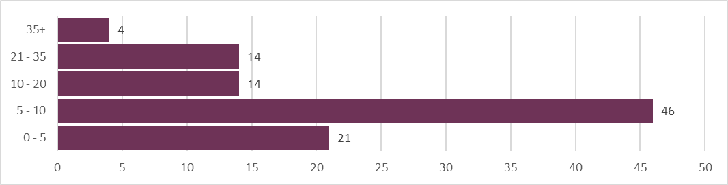

Do you hold any of the following positions within the Council? (%)
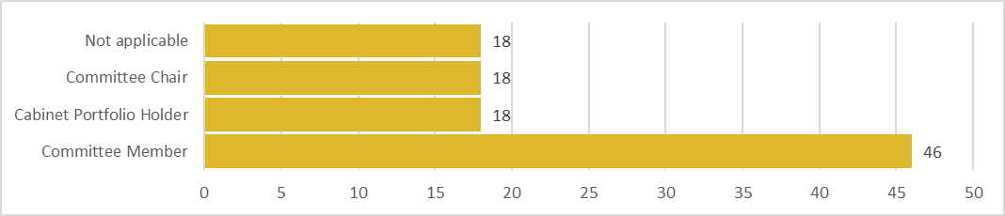
Have you been a member of a multi member ward before? (%)
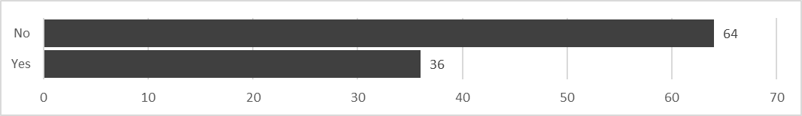
Which do you believe to be the most appropriate for the Council? (%)
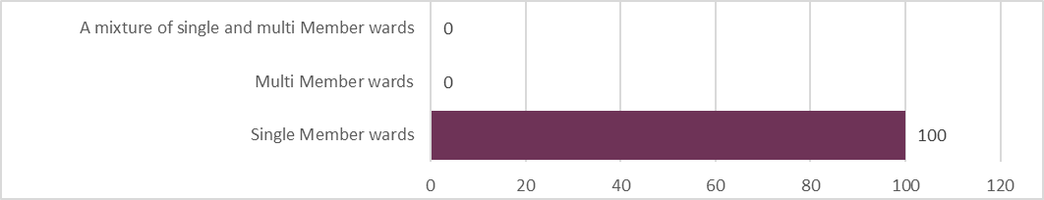
When asked to provide an explanation as to the above question, the main themes that came out were simplicity, accountability, and the difference in work ethics in multi member wards.

Many members expressed that multi member wards can be confusing for the residents, and things are much simpler with single member wards. For example “Multi member wards adds to confusion for the residents”, “If there are two members from different political parties that would and could raise difficulties with policies and to stop residents going from one cllr to another and then both cllrs could be chasing the same job or issues”. Another example of this theme comes from another member who wrote “in multi member wards it’s harder for constituents to know who has done what”.

Accountability was also a main theme which arose from the written responses. Many felt that single member wards provided more accountability and responsibility for members. For example, “You are solely accountable to the residents. A single point of contact. If you don’t work for the residents they can vote you out”, “There is a clear accountability and one named person to contact… As a councillor it also keeps you on your toes because the buck stops with you. I think it’s important the system is equitable across the district”.

The final main theme emerging from the written responses was a concern in the different work ethics between councillors in multi member wards. For example, “Having been a member of a two seat ward I found that I did all the work and the other person did very little”, “Less consistency of response from 2 Councillors, sometimes one councillor does all the work”. A further example can be found in the response “Multi member wards only work if both cllrs are of the same party, have the same work ethic and can agree some sort of division of tasks. This just doesn’t happen in reality”.

How do you communicate with your electorate? (please select all that apply) (%)
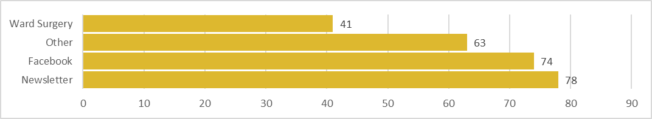
Other methods for communicating with electorate involved local community organisations, emails, telephone and ward walks. This shows that MDC Councillors currently employ a number of different methods of communicating with their electorates, both digitally and non-digitally.

Do you think the number of Councillors should be increased, decreased or remain the same? (%)
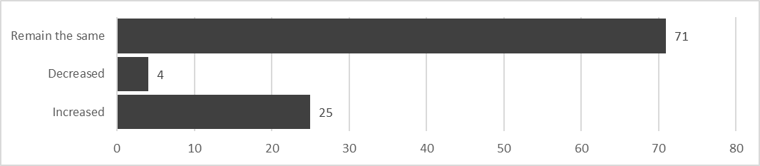
When asked to explain answers to this question, many councillors who expressed a desire to increase the number of councillors referenced the growing population of Mansfield which could potentially reflect in an increased workload. For example “Massive increase in new housing developments”, “Small increase to enable equalisation of voter numbers across wards and take into account growing population of Mansfield”.

Members who discussed decreasing the numbers suggested that the way that committees are structured could be altered in order to reduce committee workload. “If you look at the attendance of each SC there doesn’t seem to be a time when they are attended to capacity, the same could be said of the statutory committees”.

Those who said they would like the number of Councillors to remain the same have suggested that the Council have currently found a sweet spot with regards to how it is run. For example “I feel the council runs efficiently with what we have”, “I think it works well, we just need to change the boundaries slightly to even out the numbers”.

Would reducing the three Overview and Scrutiny Committees to two enable the Council to effectively undertake its overview and scrutiny function? (%)
If the number of Councillors is reduced, do you believe that the council could still operate an effective overview and scrutiny function?
Those who believed that the council could still carry out an effective overview and scrutiny function believe that the whole overview and scrutiny function could be changed in order to accommodate fewer councillors. For example “The whole structure around O/S could be changed. More scrutiny and less overview. The current pandemic has had a massive influence on the amount of scrutiny being done so maybe a smaller committee with less meetings”, “The overview and scrutiny meetings (with the exception of corporate) are currently infrequent and limited in their scope. Combining communities and place would make sense”.

A recurring theme from those who do not believe that the council could run an effective overview and scrutiny function with fewer councillors was that the workload would be too much for each member. For example, “Having less councillors would mean having to represent and attend far more meetings thus effecting the functioning of the authority with too much to attend”, “Reducing the number of councillors increases workload and reduces the amount of councillors available to sit on scrutiny panels”.

